Eventi
Analysis Model

Submitted to:

Asst. Prof. Ma. Rowena C. Solamo
Faculty Member
Department of Computer Science
College of Engineering
University of the Philippines, Diliman

Submitted by:
Lopez, Matthew S.
Dimaano, Aaron Diego I.
Torres, Jacob Angelo V.

In partial fulfillment of Academic Requirements
for the course
CS 191 Software Engineering I
of the
1st Semester, AY 2015-2016
Revision Control

History Revision:
Revision Date | Person Responsible | Version  Number | Modification
12/13/15 | Jacob Torres | 1.0 | Initial Document

System Name: Eventi

Description: Eventi is a website that aims to centralize all general events within the university and therefore providing a platform for those who seek publicity for their event as well as for those who want a single go-to site containing for everything they need to know about the events in UP.

Class Diagram: (see next page)

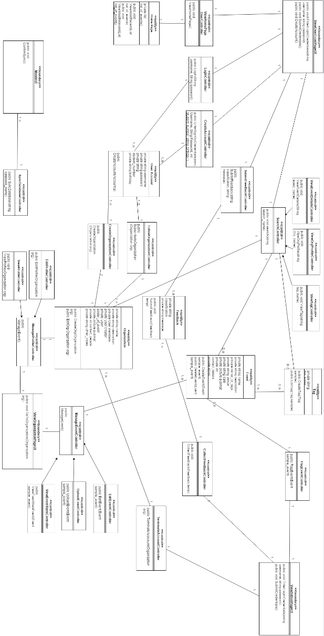

Boundary Classes:

Class Name | Description
ViewUserFrontPageUI | This boundary class is the bridge between the user (wither with account or none) and the controllers he/she has access to.

Class Name | Description
ViewHomePageUserController | This control class lets the user view the home page; the actual ink between the Home Page UI and the entity Home Page itself.

Class Name | Description
LoginController | This control class lets the users with accounts log in.

Class Name | Description
CreateAccountController | This control class lets the guest users create an account by tying in their credentials.

Class Name | Description
SubmitFeedbackController | This control class letsthe users with account submit feedback or complaint regarding what contents they see on events.

Class Name | Description
SearchController | This control class lets any user view search for their target event, organization or tag.

Class Name | Description
Home Page | This entity is the first thing the registered users see once they have logged in.

Class Name | Description
User Account | This entity represents the accounts held by the users using the web application.

Class Name | Description
FollowOrganizationController | This control class represents the capability of a user to follow organizations.

Class Name | Description
CreateOrganizationController | This control class represents the capability of a user to create an organization.

Class Name | Description
ViewEventDataController | This subpart of a control class lets the user search for a specific event on the search bar.

Class Name | Description
ViewOrgProfileController | This subpart of a control class lets the user search for a specific organization on the search bar.

Class Name | Description
ViewTagController | This subpart of a control class lets the user search for a specific tag on the search bar.

Class Name | Description
Feedback | This entity represent the feedback and the complaints that a user can do to a certain event.

Class Name | Description
Event | This entity represents the main feature of the web application, which are the events.

Class Name | Description
Tag | This entity represents a search feature of the web application, which are the tags. One can attach these into an event for easier classification.

Class Name | Description
Organization | This entity represents the group of users who created an organization. Such organizations can post and manage their events for the general Eventi community to see.

Class Name | Description
ViewAdminPageUI | This boundary class is the one the administrators see whenthey want to use the web application.

Class Name | Description
FlagEventController | This control class is a privilege of an administrator which lets him/her flag an event if it is deemed offensive or has reached the threshold of number of complaints.

Class Name | Description
CollectFeedbackController | This control class lets the administrator collect feedback given by the users for the improvement of the service of the web application.

Class Name | Description
TerminateAccountController | This control class lets the administrator end and account when that organization has too much flagged events.

Class Name | Description
ViewOrganizationPageUI | This boundary class is the user interface of the organization.

Class Name | Description
ManageEventController | This control class lets the organization manage its evnts.

Class Name | Description
EditEventContoller | This subpart of the ManageEventController lets an organization edit its events when it has posted wrong or offensive content.

Class Name | Description
UploadEventContoller | This subpart of the ManageEventController lets an organization upload its events for their subscribers to see.

Class Name | Description
ViewEventStatsContoller | This subpart of the ManageEventController lets an organization see its events' statistics; how many have seen their events, how many have complained to their events, among others.

Class Name | Description
ManageProfileController | This control class lets the organization meddle with their profile.

Class Name | Description
EditProfileController | This subpart of ManageProfileController lets the organization edit the contents it has posted on their profile.

Class Name | Description
ViewProfileController | This subpart of ManageProfileController lets the organization view the contents it has posted on their profile so it can see what the public sees.

Class Name | Description
MobileUI | This boundary class lets the mobile counterpart of this application get the contents from our database.

Class Name | Description
SyncDatabaseController | This control class lets the mobile application sync their database to ours so users can see the same content on both devices.

Control Classes:

Class Name | Description

Entity Classes:

Class Name | Description

